**17-Aug-2024**

**Internship Day - 42 Report:**

**LAB 7: DHCP (Dynamic Host Configuration Protocol):**

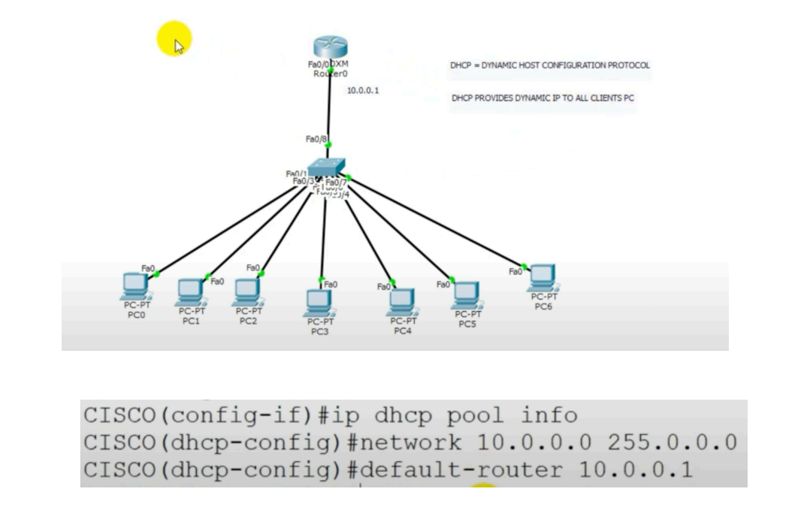

**DHCP Configuration on a Cisco Router:**

**Step 1: Access the Router’s CLI**

* Connect to the router via console or remotely using Telnet/SSH.
* Enter global configuration mode.

**Router> enable**

**Router# configure terminal**

**Step 2: Exclude IP Addresses (Optional)**

* You can exclude a range of IP addresses that you don't want to assign dynamically. This is useful for devices with static IPs (like servers or switches).

**Router(config)# ip dhcp excluded-address 10.0.0.1 10.0.0.10**

In this case, IP addresses from **10.0.0.1 to 10.0.0.10** won’t be assigned by DHCP.

**Step 3: Create a DHCP Pool**

* You need to define a DHCP pool. This is the range of IP addresses that will be assigned to clients.

**Router(config)# ip dhcp pool info**

In this example, info is the name of the DHCP pool (you can name it anything).

**Step 4: Configure the Network and Subnet**

* Specify the network and subnet mask for the pool.

**Router(dhcp-config)# network 10.0.0.0 255.0.0.0**

This configures DHCP to assign IPs from the **10.0.0.0/8** network.

**Step 5: Specify the Default Gateway (Router)**

* Define the default gateway that will be assigned to clients. This is typically the IP address of the router's interface connected to the network.

**Router(dhcp-config)# default-router 10.0.0.1**

Here, **10.0.0.1** is the default gateway for clients.

**Step 6: Specify the DNS Server (Optional)**

* If needed, configure the DNS server for clients. You can use a public DNS server (e.g., Google’s **8.8.8.8**) or a local DNS server.

**Router(dhcp-config)# dns-server 8.8.8.8**

**Step 7: (Optional) Configure Lease Time**

* By default, the DHCP lease is infinite, but you can configure a lease time if needed (e.g., 1 day).

**Router(dhcp-config)# lease 1**

This sets the lease time to **1 day**.

**Step 8: Exit and Save Configuration**

* Exit DHCP configuration mode and save the changes.

**Router(dhcp-config)# exit**

**Router(config)# exit**

**Router# write memory**

**Step 9: Verify the DHCP Configuration**

* Use the following command to verify the DHCP configuration:

**Router# show ip dhcp pool**

**Router# show ip dhcp binding**

**18-Sep-2024**

**Internship Day - 43 Report:**

Physically perform in Lab.

**19-Sep-2024**

**Internship Day - 44 Report:**

**LAB 8: DHCP (Dynamic Host Configuration Protocol) & DNS Configuration**

**DHCP Configuration Steps:**

**Enter global configuration mode:**

Router> enable

Router# configure terminal

**Create a DHCP pool:**

Router(config)# ip dhcp pool NETWORK-POOL

**Configure the network and subnet mask (as shown in your CLI):**

Router(dhcp-config)# network 10.0.0.0 255.0.0.0

**Configure the default gateway (as shown in your CLI):**

Router(dhcp-config)# default-router 10.0.0.1

**Configure DNS server (assuming Server0 will be the DNS server):**

Router(dhcp-config)# dns-server 192.168.1.4

**Configure excluded addresses (to prevent DHCP from assigning router interfaces and static IPs):**

Router(config)# ip dhcp excluded-address 10.0.0.1 10.0.0.10

**DNS Configuration Steps:**

On Server0 (192.168.1.4): Copy- Install DNS server role/service

1) Create a new forward lookup zone for your domain

2) Configure reverse lookup zone for 10.0.0.0 network

3)Add A records for:

* Router0 (10.0.0.1)
* Router1 (10.0.0.2)
* Other network devices as needed

**On the DHCP router, verify the DNS configuration is properly pointing to Server0:**

Router# show ip dhcp pool

**Additional Configuration Tips:**

**On the interfaces that will be serving DHCP:**

Router(config)# interface fa0/1

Router(config-if)# ip helper-address 192.168.1.4

**Verify DHCP operation:**

Router# show ip dhcp binding

Router# show ip dhcp server statistics

**Test DNS resolution:**

Router# ping dns-server-name

**20-Sep-2024**

**Internship Day - 45 Report:**

Physically perform in Lab.